

Reference guidelines for the preparation of photos for food portion quantification in GloboDiet

Prepared by
Sandra Crispim, Geneviève Nicolas, Viktoria Knaze, Heinz Freisling, Nadia Slimani

Based on
Van Kappel AL, Amoyel J, Slimani N, Vozar B and Riboli E. GloboDiet picture book, 1995 (including photo procedure.doc).
IARC. Guidelines on Bread Shapes, 1996.

Acknowledgment: IARC gratefully acknowledges the funding of the project by the ‘Europe Against Cancer’ Programme of the European Commission. (Grant nº SOC 96 200416).

Table of Contents
1. Introduction 2
2. Guidelines to take standardized pictures 4
3. Guidelines to prepare household measures (HHM) 11
4. Guidelines to prepare food shapes 14
5. Important points about the picture book layout & use of IARC logo 17
6. References 18
Appendix 1 – Contents of the IARC GloboDiet picture library and how to access it 19
Appendix 2 – Procedure and examples of files for adapting the existing HHM pictures for use in another country 20
Appendix 3 - Final list of HHM with measurements to be provided to IARC with local volumes and dimensions 22
Appendix 4 – Sample list of shapes chosen from the GloboDiet library. 23
Appendix 5 – Sample list of country-specific new shapes to be provided together with a sample pdf of the drawn shapes 24
Appendix 6 - Shape codes explained 26
Appendix 7 - GloboDiet picture booklet (sample inventory sheet) 27

Introduction

The International Agency for Research on Cancer (IARC) has the scientific responsibility of the GloboDiet methodology made accessible to projects and countries worldwide; the picture booklet to assess food item quantification is part of the methodology. For this reason reference guidelines to take standardised pictures of foods, dishes and household measures and prepare food shapes for use with the GloboDiet application are described in this document. The main purpose of these guidelines is to ensure that the development and choice of pictures, food shapes and household measures for use within the GloboDiet methodology is comparable across countries and studies, warranting the best possible collection of food consumption data.

These guidelines are based on the literature, on previously used GloboDiet procedures, on the EFSA expert committee opinion and on the experience from recent projects, including EFCOVAL and PANCAKE. The latter developed and tested a protocol to create pictures of food portion sizes for use among children in Europe.

GloboDiet
GloboDiet is a computer-assisted 24-h dietary recall that follows standardised steps when describing, quantifying, probing and calculating the food intakes.
To quantify portion sizes within GloboDiet, several methods can be used. Foods may be estimated with the help of household measures (e.g. a cup of tea). Foods that are consumed as more or less standard units can be counted as such (e.g. one apple, one can of beans). Other foods that are difficult to quantify by these two methods can be quantified by more visual methods, such as food shapes or pictures. If the exact volume or weight of the consumed food is known, these can also be entered directly in the system.

Existent GloboDiet picture book – How it was developed
The first GloboDiet picture book was developed in the context of the European Prospective Investigation into Cancer and Nutrition (EPIC) study in 1994/95, with the purpose of assisting subjects in estimating portion sizes when using GloboDiet¹. The foods and portions selected are representative of the situation for the 10 European countries involved in the EPIC study, which means that it can be used for other nutritional studies in Europe with similar food patterns. Data used to create the picture book was based on pilot studies carried out at the beginning of the EPIC study². For example, pilot data was used to choose the lower and higher weight extremes for each series of photos.
Some facts on the picture book:
- The book consists of 136 series of pictures of foods and recipes
- To limit the size of the book, only one series of photographs was made for different foods which resemble each other in terms of density.
- When the range was too small to show six portions with a difference in weight of at least 25%, only five or four (the minimum number) photographs were made for such picture series.
- To increase the range of possible portions, GloboDiet gives the subject the possibility to select his portion in several servings, or as a predefined fraction (1/3, 1/2, etc.) or enter an ad hoc fraction of one of the portions presented.
- All the pictures were taken from the same angle and with a similar presentation of the foods.
- Most of the foods were photographed on the same 26 cm diameter flat dish with a knife or spoon beside as a reference.
- The smaller portions are always presented on the left side of the dish and since the perception of perspective is low for pictures, increasing the surface of the portion was preferred to increasing the thickness or volume.
- The series are classified by type of food or by main ingredient for mixed foods and the portfolio system leaves open the possibility of adding or changing pages at any time.
- An index is included so that foods or groups of foods can be referred to quickly.

In addition to pictures of foods (and recipes), the subsequent GloboDiet picture booklets also include pictures of some household measures (HHM) and real-size shapes (e.g. of breads which can be used in combination with photos 58 & 59 showing thickness), a method of quantification which uses the surface area and thickness multiplied by the density of the food to get the weight of the portion consumed. More recent versions of picture booklets based on the GloboDiet methodology may also contain “help” pictures, which generally aide in identification of the food form/parts and are rather linked to standard units.

The current content of the GloboDiet picture library, encompassing all the pictures developed for different country versions of the GloboDiet applications, is presented in Appendix 1 along with additional information on how they can be obtained by the collaborators.

These guidelines detail the suggested procedure to follow when preparing pictures of foods/recipes (section 2), HHM (section 3) and shapes (section 4) all used to quantify foods. Guidelines for the preparation of “help” pictures would mirror those of section 2.

Guidelines to take standardized pictures

The development of new pictures for some food items may be required for inclusion in the GloboDiet picture booklet if photos are a good quantification method for those items and none exist for similar foods or dishes or if the consumed portion ranges are different. In that case, technical guidelines for the development of new pictures are described in Table 1, along with an indication of the comparability between the new guidelines and the procedure used to take the existing (old) pictures.
In GloboDiet, each reported food or dish will be quantified by means of a single quantification method. It must be clear that the picture series should represent a range of individual portions consumed by a subject (e.g. not a whole chicken).
Recipes in which the relative proportions of the ingredients are not stable, for example a paella where the proportion of rice and meat vary from subject to subject and can be quantified separately, should be treated as composed recipes and not as a single dish: a ‘meat paella dish’ will not be available as such in the recipe list but will be built by quantifying the portion of the rice preparation and the portion of the meat pieces separately.
A flow-chart about the procedure for new pictures is also indicated below to ensure the maximum of standardization of the photo production.
Note: To approve the selection of foods/dishes made locally, it would be helpful for IARC to receive sample pictures of the dishes/foods from websites or links to those websites.
Validation of new photos
Proofs of new photos
Selection of food items that require photos
Communication with steering committee and IARC

Standard reference photos
IARC’s approval of the food item selection #
Coding and inclusion in GloboDiet library
Improvements of photos if necessary
Final approval of new photos
Table 1 – Technical guidelines for development of pictures within the GloboDiet methodology
Technical aspect | Procedure | Comparability with old pictures
A. Selection of food items(*) that require photos  (*) food or dish/recipe | Consider:  - If a food item cannot be easily estimated with household measures or in more or less standard units(**);  - The importance of the food item, in frequency of consumption as well as on the nutritional point of view.  Potential food types to be selected (non-comprehensive list):  - Foods served in stiff mounds (e.g., ice cream)  - Foods served in loose mounds (e.g., grated cheese)  - Slippery foods (e.g., pasta)  - Foods served in sauce or gravy (e.g., stew)  - Dry food served in a bowl (e.g., corn flakes)  - Wet food served in a bowl (e.g., soup)  - Discrete pieces of different sizes (e.g., fruits)  i.e., shapeless foods and those foods that vary in individual portion size along a continuum size from very small to very large.  - Country-specific pictures of foods are required if existent pictures for general use are judged not to be appropriate. This should be, however, first agreed between IARC, a steering committee and the international/national coordinators/administrators. Validation of new photos to be added to the picture library is strongly recommended.  (**) Note that pictures are just one of the quantification methods among others; pictures may also be used to assess thickness of spreads, or to choose a standard unit (“help” pictures). | Almost the same reasoning used for the old procedure was used here. Except:  - A list of potential food types to be selected during the production of new photos was added for guidance.  - Country-specific pictures were suggested if judged necessary. This suggestion is based on PANCAKE’s experience and EFSA expert opinion.
B. Range and number of photos | - Use age-specific and population-based data to estimate the ranges of portions commonly consumed (minima and maxima).  - The distribution of the weights of portion sizes between the minimum and maximum should be distributed in linear manner in such a way that the visibility of differences between the portions is noticeable (about 25% difference between portions). After taking the photos, test if they can be ranked.  As a 25% difference between portions may not always give a nice differentiation, a log scale should be considered for some foods.  - The number of recommended photos is six. Reasons for these are:  - the difference (in weight) between two portions should be around 25% in order to be visible, and since we have chosen a linear distribution of the portion sizes between the minimum and the maximum, six photos are enough;  - all photos of one series should be visible on one page. By taking six instead of seven or eight as maximum, photos can be printed larger (9 x 5.7 cm).  - there is no evidence about differences in the accuracy of food portion quantification between 6 and 8 photos.  - Only for foods with a range that are too small for six photos, series of four or five photos can be taken. Four pictures should be enough to avoid regression towards the mean. An even number of picture is preferred. | To estimate the ranges of existent (old) pictures, population-based data were not necessarily used, but mainly data from pilot studies.  The procedure used to determine the range of photos was kept the same as the old one (minima and maxima with intervals of 25% and use of 4 pictures when 6 were too many). This is different from what has been proposed by Nelson and colleagues³ and used by the PANCAKE consortium, which used the systematic approach between the 5th and 95th percentile.  However, we judged that there was no scientific evidence to change the procedure; so we preferred to keep the comparability with the older photos and recommend the use of minima and maxima for range selection. Further investigations are needed, however.  Furthermore, two studies have proposed that 8 pictures provide more accurate results than 4 pictures^{4; 5}. Therefore, the use of four pictures with food that present small ranges deserves validation.
C. Selection of products for taking pictures | For the selection of foods, consider:  - The visual quality of foods  - Ease of preparation  - Costs  - Waste and shrinkage in preparation of the foods  - The use of frozen foods may be an option for better looking pictures if close to the visual aspect of natural foods.  The selection of reference objects (Look at the existing GloboDiet pictures for examples) should be:  - Dishes in white color (dinner plate d=26cm, soup dish d=18cm, dessert plate d=20cm).  - Stainless steel cutlery or other standard eating utensil(s) of the country (e.g. long handle spoon and chopsticks in Korea)  - Transparent glass bowl. | Old procedure was considered appropriate and maintained.
D. Preparation of foods | - The food should be presented in a usual/standard way of preparation by the population.  - Foods on the plate should look nice without losing the correct notion of volume-weight (green is a very difficult colour). Use of blanching cooking technique can enhance the colour of foods for pictures.  - The portions should be weighed on 1g precise electronic balance and the exact weights noted down directly right after for inclusion in the GloboDiet databases. Keep record of existence of inedible parts because an edible part factor may be applied.  - Measure the volume of all the foods in each portion (protocol: either pour into graduated flask if liquid or measure the difference in volume when dipped in water in a sealed plastic bag). | Old procedure was considered appropriate and improved by the addition of the recording of the volume.
E. Presentation of products on the dishes | It should:  - Be done in a standardized way and with emphasis on the visibility of differences in portion sizes.  - Have a standard fork and knife placed as references besides the dish: fork on the left hand and knife on the right hand of the plate. For foods presented in a bowl, a dessert spoon should be used, placed on the right side of the plate.  - Have smaller portions always on the left side of the dish.  - Have difference in portion size visualized in a horizontal way, which means by increasing the surface and not the thickness of the product.  - For products in slices, the dish should be turned in a way that the thickness of the slices is visible.  When necessary foods can be presented in two different ways. E.g., muesli and cornflakes in a deep dish and the equivalent in a bowl; mussels with shells on a dish and the equivalent in mussels without shells on a small dish besides it. | Old procedure was considered appropriate and maintained.
F. Photographical techniques | - Photos should be taken under an angle of 45° at a distance of 174 cm. In case of pictures for use in children, the angle should be even smaller considering that their view on a plate will be smaller compared to adults. The exact angle needs to be evaluated.  - Professional photography should be obtained in order to warranty proper conditions for taking the pictures: adequate light, resolution for printing the photos, etc. The existing GloboDiet photo series can serve as reference. | Old procedure was considered appropriate and maintained.  Note: In the case of existent GloboDiet picture book (94/95), Photos were taken using a camera Mamiya 645 PRO (6x4.5cm negative) with an objective lens of 150 mm (Mamiya 1:3.5). The diaphragm was 22 with a shutter time of 1/60sec. Flash light with diffuser came from behind and two white screens placed under 45% in the front were used to reflect a part of the light. Background was a grey granite structure with little black points.
G. Layout of the page | - The four to six photos of one series should be printed on the same page in a logical reading order and numbered 1, 2, 3...  - Photo sizes should be 9 x 5.7 cm with their temporary code under them and the title of the series at the top of the page.  - IARC will assign final codes to be shown on the picture booklet. | Old procedure was considered appropriate and maintained.
H. Responsibility | Technical work in the preparation of pictures shall be the responsibility of the project, for which one country or institute will be in charge. IARC will be involved in the approval of picture choices and of proofs, as well as the integration of the photos into the GloboDiet and its related databases. Validation of the picture series is often country-specific thus the responsibility lies with the local institute in charge of the project, although IARC can provide extensive guidance.

Example of an existent picture series in the GloboDiet booklet:

Guidelines to prepare household measures (HHM)

HHM are used to measure volumes that will be transformed into grams by GloboDiet using the specific density of a food. These measures include glasses, cups, spoons etc. Some of these HHM may be standardized across countries within a project and others are country-specific. Pictures of HHM are available at IARC and each country should select from them for its own use. Note that, if the shape of the existent HHM is overall suitable, the total volume can be adapted. It is however wise to check the dimensions of the original HHM and the local HHM are not too different otherwise the photo will look awkward. Separate guidance is provided to adapt existing pictures (see Appendix 2).
If the existing photos are not suitable and the preparation of new photos for HHM is required, the guidelines given below should be followed. A flow-chart for HHM preparation is also given:

Selection of HHM

Coding and inclusion in GloboDiet library
Final approval of HHM photos
Proofs of HHM photos
IARC’s approval of HHM selection

Standard reference photos
Improvements of photos if necessary

Communication with steering committee and IARC

Furthermore, it is not necessary to photograph all the household measures available in a country/region. Pictures are not needed particularly for those HHM that are quite common/standard thus vary little within a country/region (e.g. ladles, spoons, plastic or cardboard cups). However, during the interview, their dimensions should still be checked as several sizes may co-exist. The interviewer will have a separate sheet of paper with the dimensions and corresponding HHM codes. Alternatively, the dimensions of these cups may be indicated in the name of the HHM.

Selection of household measurements:
New HHM picture(s) may be required if a very popular country-specific HHM is judged to be missing from the general available list in the library and subjects/interviewers may have difficulty identifying it/its size without a picture available. As for the pictures of foods, the preparation of new HHM should be first agreed between IARC, a steering committee and the international/national coordinators/administrators of a given project.

Preparations of HHM pictures:
The pictures should be taken:
- on a white table
- under approximately 90º angle for glasses and cups (with visible top rounding of all the measures) and approximately 45º angle for dishes
- including a coffee spoon for reference
- with a maximum of 4 items (e.g., glasses) per picture; fewer items are preferable
- with professional conditions (adequate lighting, resolution, etc.)

Presentation of HHM pictures to be included in the picture booklet together with the pictures of foods:
All pictures should be shown on the same scale to that it is visually possible to compare them. The pictures should be fixed per two sets on A4 pages with their codes below. Outer dimensions (in cm or inches) of each HHM should be indicated so that the choice of the glass can be checked and validated during the interview. This should be preferably done in software that will allow the inclusion of dimensions and fraction lines afterwards (e.g. Microsoft Word). We advise the following order for country-specific HHMs: wine glasses, strong alcohol glasses, beer glasses, juice/water glasses, coffee/tea cups and mugs, bowls and dishes.
After placing the pictures on the pages, the measures of different possible intakes need to be indicated by fraction lines in the HHM (except cutlery). For this:
The real HHM should be filled with water up to the rim (representing the full volume of the HHM) and weighed using an electronic calibrated balance with precision of 1 gram. This refers to the total volume (corresponding to fraction=1).
The total volume should be recorded for posterior inclusion in the GloboDiet databases. Then, fractions should be calculated as a function of the form/shape of the glass and the full filling established in the previous steps.
- For low and large models, use: 1/6, 1/3, ½, 2/3 and 5/6 or ¼, 1/2 and 3/4
- High and tall models, use 1/8, ¼, ½, ¾, 7/8
The height of each fraction depends on the shape of the HHM thus a ruler will need to be placed on the inside of the HHM to note the distance (in cm) from the inside bottom of the glass or of the “liquid containing body” to the top of the liquid when filled to the volume of the fractions measured. Note down these distances in a spreadsheet (see Appendix 2 for an example). These fraction distances will need to be scaled down later (from the true size/distance) to the final size of the HHM in a picture as printed.
Black lines indicating the total filling (fraction=1) and the other fractions should be ‘drawn’ on the pictures already fixed on the A4 sheets and scaled down/up appropriately. A figure (1, ¼…) should be entered at each line (see below for an example of HHM pictures).

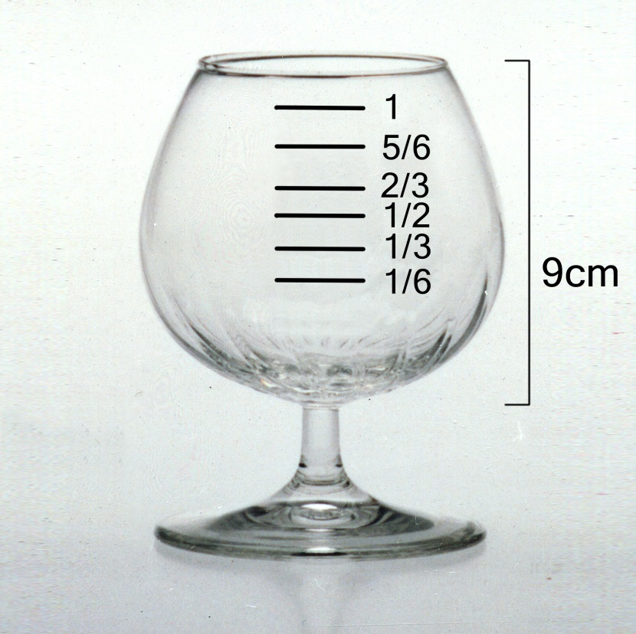
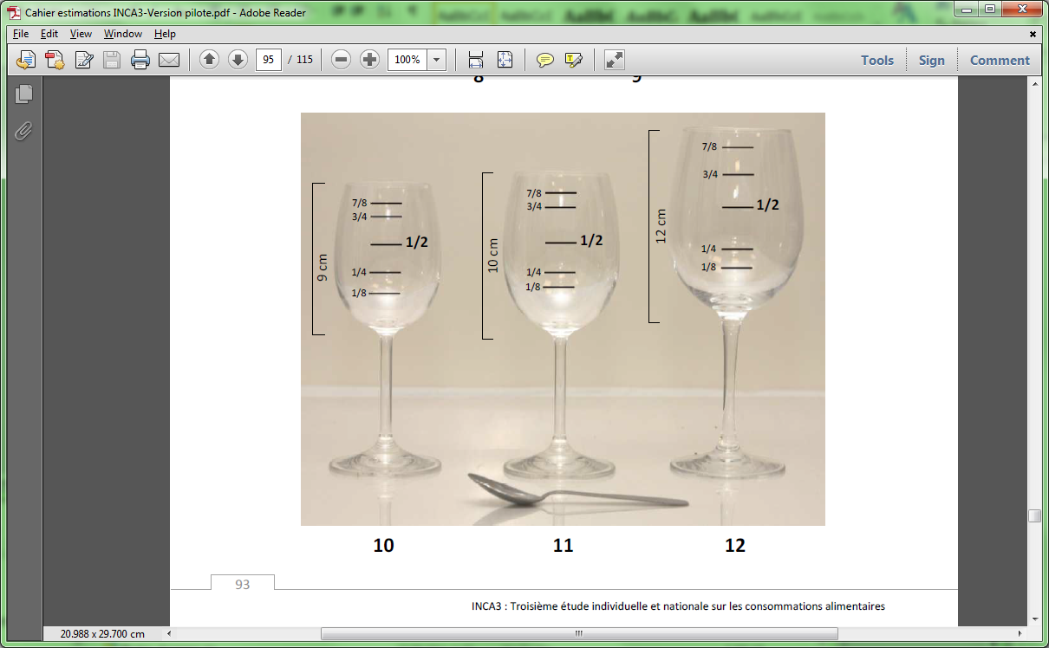

Note: Pictures of HHM from previous studies may not have followed these guidelines thus the fraction of 1 or the presentation of the outer dimensions could differ slightly from the current guidelines, depending on the source of the photos.

In addition, the picture should indicate either the height for glasses, or diameter in cm for bowls or deep plate, of each HHM (except cutlery). However, all the relevant dimensions (outer diameter, total height, liquid containing body height) of the HHM should be measured for IARC’s records (Appendix 3). It is not necessary to show the diameter, in addition to the height, in the picture of the glasses (so that it does not look too cumbersome). However it is recommended for pictures of food bowls and large dishes. To facilitate the use of HHM within the GloboDiet methodology, a true-scale ruler should be placed in the picture book (usually on the last page) for reference.

Attention (see also examples of common glasses below):
- In case of a glass with a thick bottom, do not separate the bottom from the total height: indicate only the total height as measured on the outside.
- In case of a glass with a stem, indicate the height of the liquid containing body from the end of the stem to the top of the glass; in addition, measure the total height of the glass
- For the diameter, measure it for your own records in these zones of the glass:
- at the rim in case of cylindrical (like highball/long drink glasses), conical (like Rocks/whisky, shot, Martini or Champagne glasses) and Cocktail glasses;
- at the widest part for Brandy/Cognac or Wine glasses.
Refer to the names and shapes of the glasses below
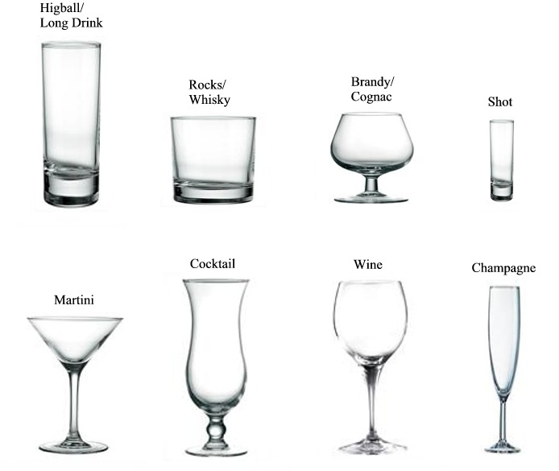

Tip: to reduce the number of photos, the same photo may be used for glasses that have the same shape but different sizes. In that case, several codes will be indicated below the picture. The heights of the HHM will also be indicated near the picture in order to check which measurement fits best (the diameter is assumed to be proportional to the height).

Guidelines to prepare food shapes

The quantification of portion sizes by means of food shapes is a new procedure within GloboDiet. Up to now, bread shapes were only created to quantify fats on breads by means of so-called virtual photos. This new quantification method allows quantifying breads, rusks, cakes and similar food items as well as their toppings (fats, jams, honey, cheese spread, liver pate…) by multiplying the surface area of the shape by its reported thickness to get the volume and then using the specific density of the food to convert the portion consumed into grams. Use of shapes concerns only flat items with even thicknesses (e.g. rusks) or items which may be commonly sliced resulting in an even thickness (e.g. slices of bread, cake, or zucchini). This quantification method cannot be used for items with irregular thicknesses (e.g. buns, balls, waffle, kugelhopf…) or with slices containing holes (e.g. melon, sweet pepper, pumpkin, Emmental cheese…).
It should be kept in mind that, depending on the country, some breads and other food items may be quantified more easily using standard units (e.g. buns of different diameters), which will be considered and evaluated by IARC in the process of approval.

Foods for which the shapes method would be a suitable quantification method are those that have either very geometrical shapes (e.g. circular such as pizzas and pies or squared such as sandwich breads) or irregular shapes that vary for a given food but are commonly sliced in such away so that the thickness/height of the shape can be easily estimated because it is flat (e.g. bread slices, terrine or brioche slices). Keep in mind however, that standard units may be a more suitable method of quantification, especially if the thickness/height of the food doesn’t vary too much (e.g. crème brule).

It is recommended to first make an inventory of all the shapes needed in your country by considering the foods in your local FDLIST file. In particular, compile a) a group of bread slices that may be representative for the bread shapes in your country and b) other shapes that would be needed to quantify by shapes such as cakes, terrine, pate, pizzas.

A number of shape pictures are already available in the GloboDiet picture library at IARC. Check if drawings of shapes for your study may already be available in the library for the foods needing shapes identified in the previous step. Note down the shapes needed for your country from the available drawings of shapes found in GloboDiet picture booklets. See sample table in Appendix 4. Provide this to IARC for verification and approval. Have in mind that not all shapes need a drawing, e.g. a piece of brownie 5 by 6 cm makes 30 cm² and can be directly entered in your local GloboDiet version by choosing a rectangular shape having a surface area of 30 cm².

Note: Shapes in the picture books are drawings in real-size and their surface areas have already been estimated and are stored in the GloboDiet library database. The shape code can give you an indication of the surface area of the given shape; see 'Shape codes explained' in Appendix 6. Thus if you borrow a shape drawing from another country (along with its code), the size of the drawing must remain the same to assure that the surface area is kept unchanged.

Then prepare a list of foods needing new drawings of shapes also to be included in your local picture booklet and which would be subsequently added to the GloboDiet picture library.
If new shape drawings are needed, the guidelines for their preparation, along with a flow-chart follow below:
Selection of shapes

Coding and inclusion in GloboDiet library
Final approval of shapes for printing
Proofs of selected shapes
IARC’s approval of shapes selection

Standard reference shapes
Improvements of shapes if necessary

Communication with steering committee and IARC

To prepare new shapes for approval by IARC (see Appendix 5)
1) Draw the shapes in real size (e.g. by drawing the outline of the shape) on mm block/grid paper and give each shape a temporary code (1-n) along with a shape description specifying which food(s) it will refer to (e.g. oval bread/flat bread) and send pdf scans of the shapes to IARC for verification/approval. IARC will later assign final codes to the approved shapes to be shown in the picture booklet based on the list in IARC’s reference file M_SHAPES.
2) For the approved shapes, calculate the surface area (with the aid of the block/grid paper if need be). These surfaces (in cm²) will be incorporated in a specific GloboDiet database (M_SHAPES). A minimum of 10 cm² difference is applied between two successive shapes.
3) Identify the common thicknesses of slices/pieces corresponding to the shapes. Take into account that foods may be bought precut, but may also be cut at home. A range of minimum and maximum thickness for each of the shapes (e.g. for crepes, for the bread slices) should be also provided to IARC. Those thicknesses (in cm) will be incorporated in a specific GloboDiet database (THICKNESS) in line with the food and recipe classification (sub)-groups where they should be proposed. For thicknesses, pre-defined common thicknesses will be available in the ES database, ranging from 1 mm to about 30 cm by default.
4) For each food and recipe, a density coefficient calculated as weight/volume, with weight in g and volume = surface x thickness in cm³, will have to be provided. These densities can be measured using the aforementioned parameters or obtained from other local/national sources, if such data exists.
5) For the final print of the shapes, the drawings will need to be scanned in true size (without using the zoom function on the scanner) and the lines redrawn so that the lines appear smoother and without the block/grid in the background. Other shapes may be drawn directly using any appropriate computer software for this purpose. The final picture of the shape will be presented on A4 sheet in true scale. A true-scale ruler can be placed next to the shape for reference and for the subject to estimate the thickness of the shape during the interview (see example below, note that it is not true scale here).

Example of a food (bread) shape (N075 = bread loaf shape, surface 70-79 cm²). Note: this picture is not to scale and wouldn’t appear as such in the actual picture booklet.
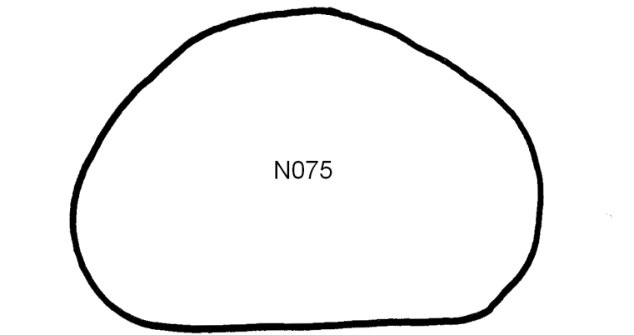

Important points about the picture book layout & use of IARC logo

The final picture booklet should include (see Appendix 7):
  - Front cover including the name of the study, all institutes involved in the preparation and their logos. Only in case the picture booklet is used with the GloboDiet software and has been thoroughly checked by the IARC-DEX team, the official IARC logo in high resolution will be made available to the partner after the proof of the front cover is sent to IARC (com@iarc.fr) for approval. Permission for the use of the IARC logo must be obtained from com@iarc.fr for each and any subsequent edition of the booklet.
  - Table of content
  - Specific photo sections (including photos, shapes, HHM, true size ruler, true size serving plate, etc.)
  - Acknowledgments on the sources of photos (either after the table of contents or on the back cover)
  - Any other relevant section specific to the study
  - Back cover
Only in case the picture booklet is used with the GloboDiet software, the picture booklet proofs, including the front and back covers, will need to be sent to IARC-DEX for approval prior to their printing and use in the field (i.e. before the final version of the local GloboDiet application is released). A couple of reasons necessitate this. First, the technical team from IARC’s Dietary Exposure Assessment (DEX) group will need to make final checks of all the codes, names/translations for accuracy and completeness. If any discrepancies are detected between the picture booklet proofs and the local GloboDiet version, corrections must be made either in the application or the picture booklet proofs (to be determined by the DEX team) before they are used. Second, IARC has a strict policy on the use of IARC’s logo and any proprietary tools of IARC (i.e. GloboDiet) in any published (printed, electronic or web) material by external parties. Therefore, prior to the printing of the picture booklet the use of IARC/WHO logo and the wording related to the use of GloboDiet methodology will need to be approved by IARC. Thus a written of request will need to be submitted by the collaborators outlining the use of the logo and specifying the wording to be used in reference to the GloboDiet methodology. This is rather a formality but nevertheless IARC’s logo should not be used by any external parties (print, electronic, or web) unless this explicit written permission has been granted by IARC’s Communications group. New developed pictures will belong to the producers but should be made available with free access if used within the GloboDiet methodology.

References

- van Kappel AL, Amoyel J, Slimani N et al. (1995) EPIC-soft picture book for estimation of food portion sizes. Lyon, France: International Agency for Research on Cancer.
- Kaaks R, Slimani N & Riboli E (1997) Pilot phase studies on the accuracy of dietary intake measurements in the EPIC project: overall evaluation of results. European Prospective Investigation into Cancer and Nutrition. International Journal of Epidemiology 26, S26.
- Nelson M & Haraldsdottir J (1998) Food photographs: practical guidelines II. Development and use of photographic atlases for assessing food portion size. Public Health Nutr 1, 231-237.
- Nelson M, Atkinson M & Darbyshire S (1996) Food photographs improve estimates of nutrient intake in dietary surveys. Proc Nutr Soc 56, 205A.
- Subar AF, Crafts J, Zimmerman TP et al. (2010) Assessment of the accuracy of portion size reports using computer-based food photographs aids in the development of an automated self-administered 24-hour recall. J Am Diet Assoc 110, 55-64.

Appendix 1 – Contents of the IARC GloboDiet picture library and how to access it

The content of the GloboDiet picture library can be shared with the local partners on request via a dedicated ftp site (filedepot.iarc.fr) set up by IARC. Due to the limitations regarding the size of the files on the ftp site, the content may have to be provided in parts. Currently, the library includes pictures from:
  - EPIC study (included Denmark, France, Germany, Greece, Italy, the Netherlands, Norway, Spain, Sweden, and UK )
  - EFCOVAL study (included Belgium, Czech Republic, France, the Netherlands, Norway, Denmark and Spain)
  - PANCAKE (included Belgium, Czech Republic) and PILOT-PANEU studies (included Bulgaria, Finland, Hungary and Portugal)
  - National studies in Belgium, France, Germany, the Netherlands, and Switzerland
  - Korea

For choosing the pictures, pdf format files are available. For preparing the picture booklet, jpeg and/or tif formats are preferred and are also available from IARC on request.

Folder Photos: The food photos will be accompanied by the weights of each of the series in a spreadsheet format, M_PHOTOSglobal.xls and guidelines on their use PHOTO.doc.

Folder HHM: Household measures pictures.

Folder Shapes: Surfaces (sometimes with old ‘58’ (EPIC) or ‘99’ (EFCOVAL) codes).

Appendix 2 – Procedure and examples of files for adapting the existing HHM pictures for use in another country

HHM are used to measure volumes that will be transformed into grams by GloboDiet application using the specific density of a food. These measures include glasses, cups, spoons etc. The recommended procedure is as follows:

- List all the household measures (associated with volume) that will be needed in your local survey (e.g. serving spoons, bowls, glasses) and should be available in your local version of GloboDiet (Column 1 from the left, in the Table 1 below). The name of the HHM should be in your local language.
- Provide the English name for your HHM (Column 2 of Table 1)
- Provide the total volume, to the rim of the HHM, as found in your country (Column 3 of Table 1).
- For each of the pictures listed in your HHM list (Column 1), decide whether you wish to have a picture of it to aid the interviewees in identifying the correct HHM. Indicate this in Column 4 of Table 1. Note that it is not necessary to photograph all the household measures available in a country/region. Pictures are not needed particularly for those HHM that are quite common/standard thus vary little within a country/region (e.g. ladles, spoons, plastic or cardboard cups).
- For those HHM where a picture would be needed, search through the GloboDiet library to see if one of similar shape may already be available from another country / project. Note that, if the shape of the existent HHM is overall suitable, the total volume can be adapted. If a suitable picture/photo is available, provide the code of a HHM from the GloboDiet picture and the original HHM name as it appears in the GloboDiet picture booklet of that country in Columns 5 and 6, respectively.
- Provide this file to IARC for approval. For HHM where pictures have been selected from the GloboDiet picture booklets, IARC will check to see if the original and the country-specific volumes and dimensions of the HHM are comparable. If not, they will have to be adapted and the local team will need to provide new dimensions for their HHM of different volumes. See Table 2 below for an example of how two HHM pictures were adapted for country ‘X’ from the existing HHM originally used in France and the UK.
- For those HHM needing a photo to aid during the interview but no suitable photo could be found in the GloboDiet picture library, new photos will need to be prepared for them. In such case, follow the procedure in Section 3 “Guidelines to prepare household measures (HHM)” at the beginning of this document on how to prepare new photos.

Table 1: List of all the HHM needed in the local GloboDiet version, their names and volumes to be provided to IARC for inclusion in the local GloboDiet version.

Local HHM name | English HHM name | HHM volume (as is in your country) | Is a picture needed (Y/N) | HHM code from GloboDiet picture booklet (if a picture is needed) | Original HHM name (as it appears in the GloboDiet library picture booklet)
Xxx | Glass, wine | 50 | y | FR1-35 | verre, eau de vie
Yyyy | Glass, juice | 250 | y | UK1-41 | Glass, juice (large tumbler)
zzz | Spoon, coffee | 5 | N | - | -

Table 2: In the example below, the existing HHMs from France and the United Kingdom were selected to be used in country ‘X’ as the shapes of the HHM are suitable. The data on those HHMs are the following:

HHM code from GloboDiet picture booklet (if a picture is needed) | Original HHM name (as it appears in the GloboDiet library picture booklet) | HHM volume [ml] | Fractions | Diameter [cm] | Total height (from bottom to top) [cm] including the stem if the case. | Outer height of the liquid containing "body" [cm] | *Total internal height of the “liquid containing body” [cm]
FR1-35 | verre, eau de vie | 60 | 1/6,1/3,1/2,2/3,5/6,1 | 4.4 | 8.1 | 5.5 | 4.5
UK1-41 | Glass, juice (large tumbler) | 360 | 1/6,1/3,1/2,2/3,5/6,1 | 8.1 | 9.6 | 11.0 | 9.4

FR= France, UK= United Kingdom

Country ‘X’ will need to check if the dimensions reported by France and the United Kingdom (above gray columns) need to be adapted for use in its own country. The new volume, fractions and dimensions will be provided to IARC. The measurements to draw the new fraction lines will also be provided. They are measured from the point where the liquid containing body is filled.

HHM code | Adapted HHM name | HHM volume [ml] | Fractions | Diameter [cm] | Total height (from bottom to top) [cm] | Outer height of the liquid containing "body" [cm] | *Total internal height of the “liquid containing body” [cm] | Measurements for the fractions from the inside of the glass [cm]
XX1-35 | Glass with stem, rakia | 50 | 1/4, 1/2, 3/4, 1 | 4.0 | 10.0 | 6.0 | 5.0 | 1.8, 3.0, 4.0, 4.5
XX2-41 | Glass, large, whiskey | 250 | 1/6, 1/3, 1/2, 2/3, 5/6, 1 | 8.0 | 8.8 | 8.8 | 7.8 | 2.5, 3.5, 4.5, 5.2, 6.2, 7.3

* This height is measured on the inside of the liquid containing body to the rim.

Appendix 3- Final list of HHM with measurements to be provided to IARC with local volumes and dimensions

Date of measurements: |  | 1999
HHM code in local GloboDiet | HHM name | HHM volume [ml] | Fractions | Diameter  [cm] | Total height  [cm] | Height of bowl, if applicable [cm]
31 | verre, coupe champagne | 170 | 1/4,1/2,3/4,1 | 8.6 | 10.4 | 3.9
32 | verre, petit vin | 190 | 1/8,1/4,1/2,3/4,7/8,1 | 6.8 | 13 | 6.5
33 | verre, grand vin | 245 | 1/6,1/3,1/2,2/3,5/6,1 | 6.2 | 16.1 | 9.6
34 | verre, flute champagne | 180 | 1/8,1/4,1/2,3/4,7/8,1 | 4.4 | 17.9 | 11.2
35 | verre, eau de vie | 60 | 1/6,1/3,1/2,2/3,5/6,1 | 4.4 | 8.1 | 5.5

Appendix 4 – Sample list of shapes chosen from the GloboDiet library.
Shape code from GloboDiet library (other than D codes) | Country of the picture booklet from which originates the shape code | Surface area (cm2) | Shape's description to be used in the local picture book | Any comment, e.g. for which foods in the local food list is this shape applicable | Range of thicknesses associated with each shape* | Densities measured while gathering the shapes (associated with each food)
R015 | Switzerland | 15 | Bread/brioche slice, rectangular | For rectangular breads (e.g. country-style) and also sweet brioche loaf | 1-6 cm | Country-style bread = 0.45, Sweet brioche = 0.53
R065 | Switzerland | 65 | Bread/brioche slice, rectangular | For rectangular breads (e.g. country-style) and also sweet brioche loaf | 1-6 cm | Same as above
S085 | France | 85 | Bread slice, square | For refined wheat or wholemeal breads (e.g. sandwich bread) | 0.5-2.5 cm | Refined wheat bread = 0.3, Wholemeal sandwich bread = 0.4
W075 | France | 75 | Braided loaf slice | For loaves braided or some brioche type breads, of similar shapes | 0.7-2 cm | will be provided later
*The range of thickness should include the minimum and maximum thickness of all the foods considered for a given shape code

Appendix 5 – Sample list of country-specific new shapes to be provided together with a sample pdf of the drawn shapes

Group | Temporary code | surface [cm²] | description | Any comment | Range of thicknesses associated with each shape* | Densities measured while gathering the shapes (associated with each food)
1 | A1 | 20 | Round bread | For round breads (e.g. country-style) and also sweet brioche loaf | 1-6 cm | Country-style = 0.45  Sweet brioche = 0.53
1 | A2 | 40 | Round bread | For round breads (e.g. country-style) and also sweet brioche loaf | 1-6 cm | Same as above
1 | A3 | 59 | Round bread | For round breads (e.g. country-style) | 1-3.5 cm | Same as above
2 | S1 | 80 | Square bread | For refined wheat or wholemeal breads (e.g. sandwich bread) | 0.5-2.5 cm | Refined wheat sandwich bread = 0.3  Wholemeal sandwich bread = 0.4
2 | S2 | 102 | Square bread | For refined wheat or wholemeal breads (e.g. sandwich bread) | 0.5-2.5 cm | Liver pate = 0.94  Terrine = 1.00
3 | P1 | 63 | Pate/fish cake | For liver pates, fish cakes, terrine | 1-5 cm | Same as above
3 | P2 | 88 | Pate/fish cake | For liver pates, fish cakes, terrine | 1-5 cm | Same as above
*The range of thickness should include the minimum and maximum thickness of all the foods considered for this shape

Appendix 6 - Shape codes explained

The shape code is a combination of a letter and a number. In the current coding system, the letter code has a meaning describing the shape (e.g. D, S and R codes, see below, F for 'flat' or W for 'weird'). The number part of the code represents usually the surface area in cm² however for D codes it represents the diameter associated with it. For example, a code of F065 is for a food with flat shape having a surface area of 65cm² whereas D025 is for a food of circular shape where the diameter of the food is equal to 25cm.

Shape codes starting with a letter S are for squared shapes where the surface area can be calculated by squaring one side of the shape (i.e. side length²). Thus a ruler can also be used to easily calculate the surface area of this shape during the interview which can then be entered into the GloboDiet application directly.

Shape codes starting with a letter R are for rectangular shapes where the surface area can be calculated by multiplying the long side of the shape by the short side (e.g. length x width). Thus a ruler can also be used to easily calculate the surface area of this shape during the interview which can then be entered into the GloboDiet application directly.

Shape codes starting with a letter D are for circular shapes only and should be used for foods where a diameter can be identified by the subject. Thus a code of D025 is for a food of circular shape where the diameter of the food is equal to 25cm. GloboDiet calculates the surface area of circular shapes using the formula A=πr², where r is half of the diameter indicated by the subject.

Some countries decide that a real size ruler alone can be used by the subject to estimate the diameter of foods having circular shapes. Other countries include in their picture booklet drawings of circles with different diameters or fractions of a circle to aid the subject in the estimation of the diameter and portions of a circle/pie consumed.

Appendix 7 - GloboDiet picture booklet (sample inventory sheet)

Below is an example of a document listing by page numbers the full contents of a country-specific picture booklet. Such document should be prepared and sent to IARC for verification along with the proofs of the pictures. It will also be needed for the printing company producing the picture booklets. Different colors in the example represent different sections in the photo booklet.
Page-Nº | Order* | ® |  | contents / photo number |  |  | English name | Translation | Comments
1 | 1 |  |  | Front-page | with ruler |  |  | A | BE_frontcover.pdf
 | 2 |  |  | Household measures
2 |  | 1 |  | HHM1 | inside front page |  |  | bekers/glazen | bekersp1.57.pdf
3 |  | 2 |  | HHM2 |  |  |  | glazen | glazenp1.59.pdf
4 |  | 3 |  | ............ |  |  |  | ....... | .......
 | 3 |  |  | Bread shapes
5 |  | 1 |  | bread shapes | with ruler |  |  |  | BE_breadshape1of7 version Aug 21.pdf
6 |  | 2 |  | bread shapes | with ruler |  |  |  | BE_breadshape4of7 version Aug 21.pdf
7 |  | 3 |  | ……… | …… |  |  |  | …….
 | 4 |  |  | Photos foods/recipes
10 |  | 1 |  | 57 | butter |  | Butter | Boter | PB_057.tif
11 |  | 2 |  | 99 | butter |  | Margarine | Vetstof op brood | Butter on bread_99.pdf
12 |  | 3 |  | 1 |  |  | Potatoes, boiled | Aardappelen, gekookt | PB_001.tif
13 |  | 4 |  | 509 |  |  | Chili con carne | Chili con carne | PB_509.tif
14 |  | 5 |  | ……. |  |  | ….. | ...... | …….
 | 5 |  |  | Additional pictures (if needed?)
8 | Middle booklet |  |  | plate | A3 format folded | black and white | Plate | Bord | plate for middle pages.pdf §
9 |  |  |  | Plate | A3 format folded | black and white
 | 6 |  |  | Back page
15 |  |  |  | back page (colophon) |  | black and white |  |  | BE_back cover version Aug 21-ok.pdf
* Order in which the pages need to be compiled in the booklet, ® Sub-order, § It is recommended to foresee an even number of pages in this table (if necessary add an empty page where you prefer it in order to make it even). In case the total number of pages is uneven, an empty page will be added by the printing company.

Modified from the Belgian GloboDiet picture booklet inventory.

